VPC TASK-1

- Create 1 custom VPC network
- Create 2 subnets (Private subnets)
- Create 1 VM in each subnet. (VM should have only private IPs and no Public IPs)

Task:
1. Look at the VPC routes without any subnets in it.
2. Look at the VPC routes after subnet creation.
3. Look at the VPC route to the internet gateway.
4. Demonstrate how to ping from VM1 to VM2, but not from VM2 to VM1
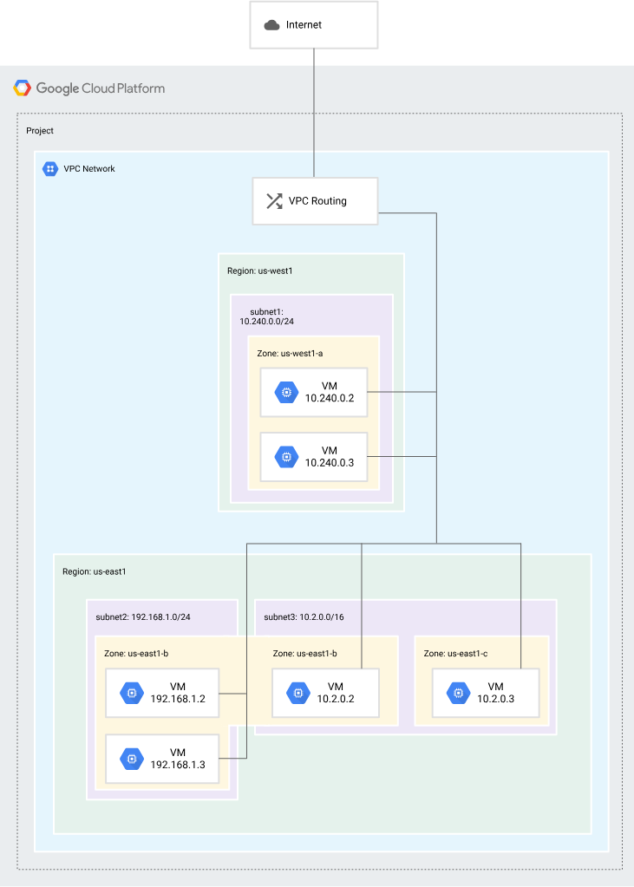

Implementation:

- Configure 2 private subnets in a vpc network

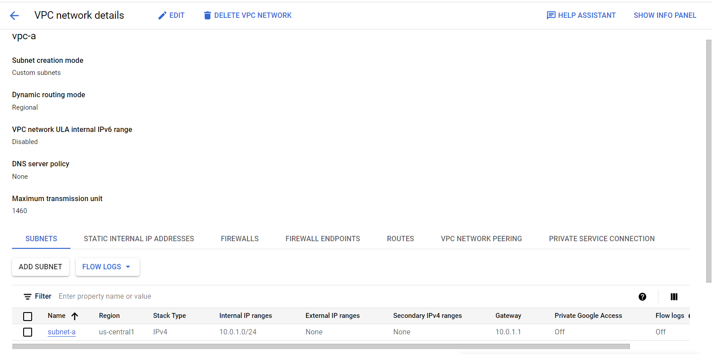

- Create two compute instances with external ip address as None.
- Note down the internal-ip address
- All the instances will belong to the CIDR range that we had provided to the Subnet of respective vpc’s.

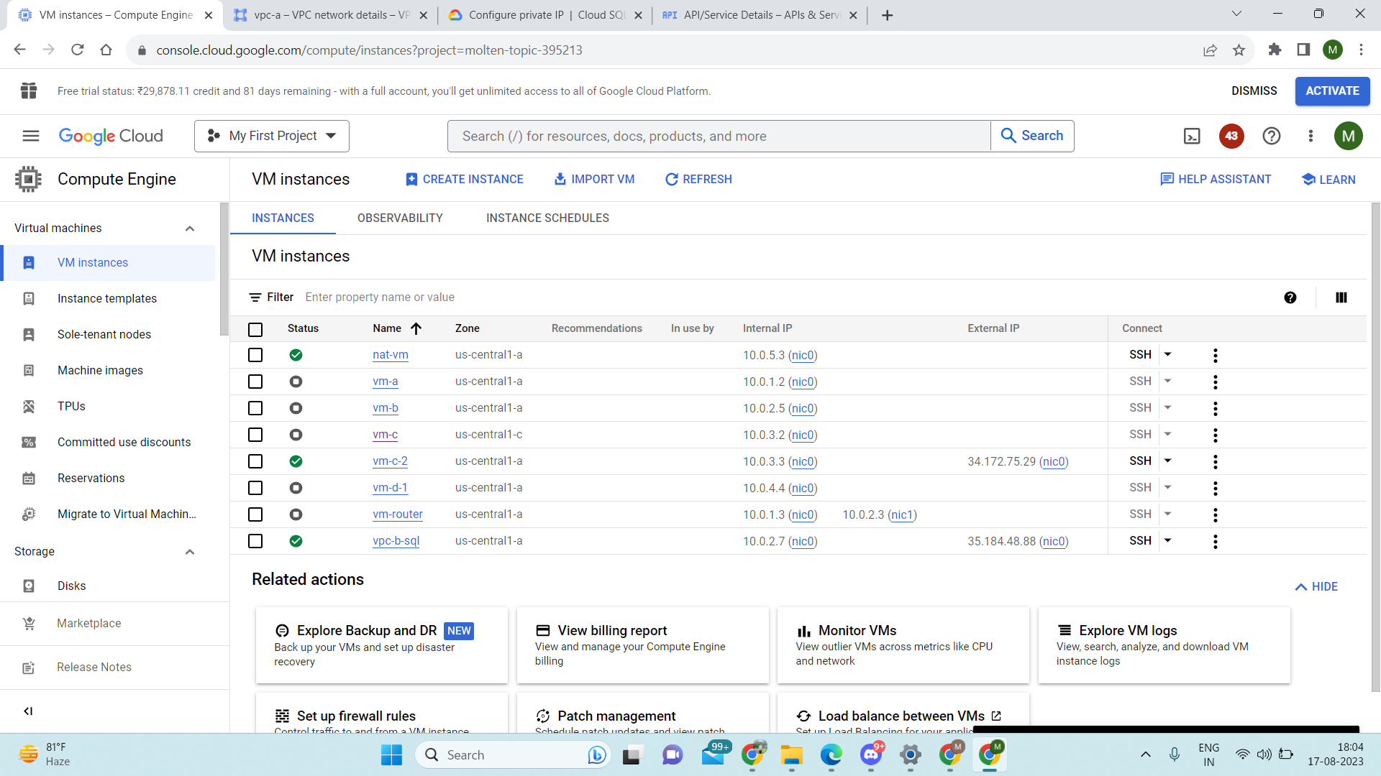

Now observe the following points in the Routes-
- Without subnets being created you only view the default static route to 0.0.0.0/0 going to the default internet gateway.

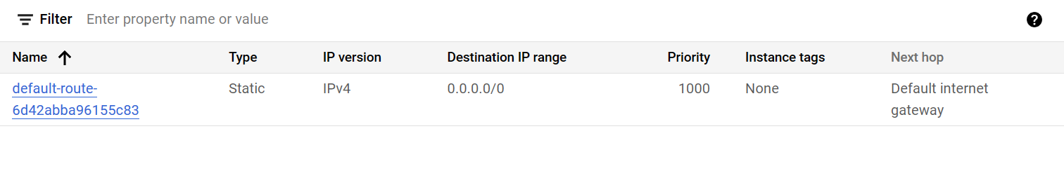
2.After Creating the subnets,check the system-generated subnet route
Created automatically for each subnet IP address range which forwards packets to VMs and internal load balancers.

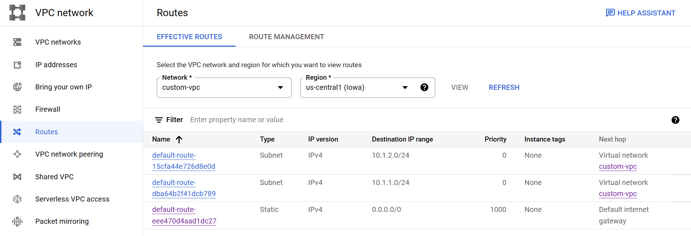

VM-1 address 10.1.1.2
VM-2 address 10.1.2.2

Now u have to ping VM-2 from VM-1, but not VM-1 from VM-2
By default pinging is off, so we can ignore second condition

So what does the statement “ ping VM-2 from VM-1” mean?
It simply means when you ssh into VM-1 and try to access VM-2 from there you should be able to do that .

- in your custom-vpc, set a firewall rule to ingress requests from source ranges of the subnet containing VM-1.

VM-1 SSH (Can access VM-2 from VM-1)

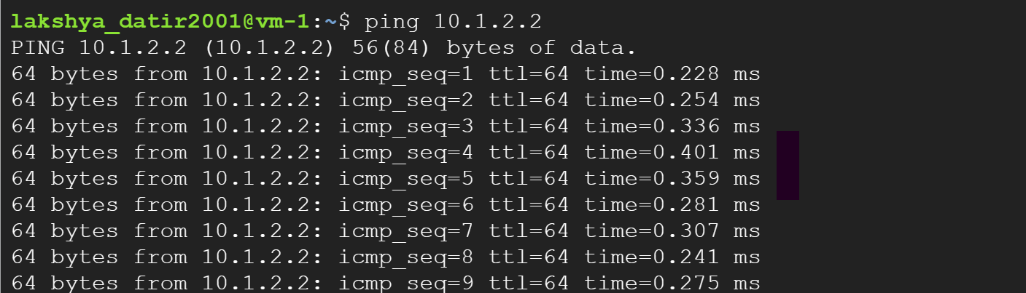

VM-2 SSH (Can’t access VM-1 from VM-2)

